|  |  |  |
| --- | --- | --- |
| Bangalore Shivacharan – CEO | David Hong – product manager | Nayanjeet Medhi |
| Jamey Money - User | Marguerite Rogers - User | JC |
| Steve Levis - User |  |  |

The updated mockups were discussed.

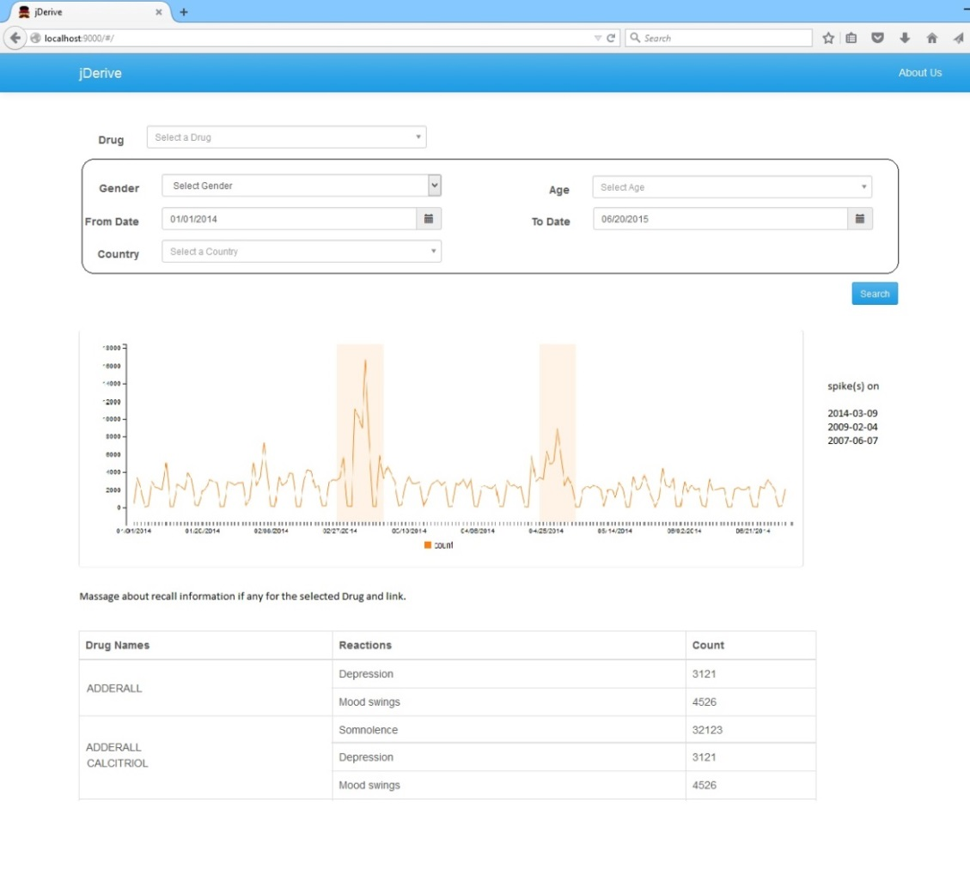

Mockup v3

**Comments:**

1. Add a radio button to get data either from local DB or OpenFDA interface.

2. Add facility to zoom into a timeline.

3. Show recall data on the mockup.

4. The details of the comments were added as issues in GitHub. <https://github.com/TPRockville/dAnalytics/issues/20>

<https://github.com/TPRockville/dAnalytics/issues/22>

Screenshot of the Github tickets.

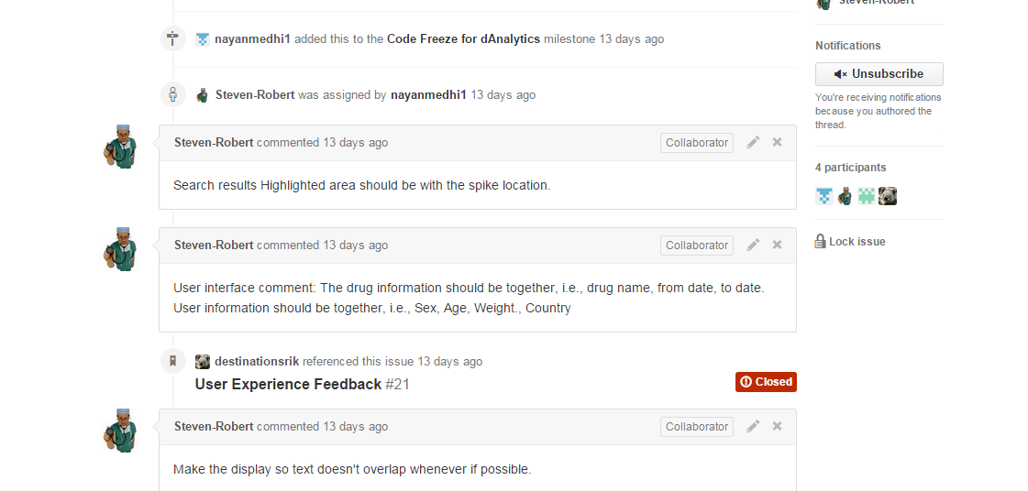

The Search Fields were re organized based on the End User Feedback. The updated search field is shown below.

